Goals for Special Olympics Australia is a Corporate 6 aside Football Challenge to generate staff cohesion and team building.
WHEN: THURSDAY 19th NOVEMBER 2015
TIME: 5.00pm Kick off
WHERE: LILYS FOOTBALL CENTRE, 5 QUINN AVE SEVEN HILLS
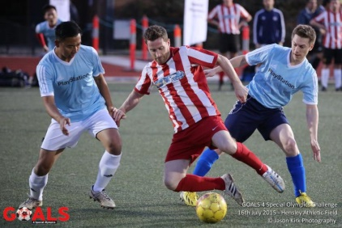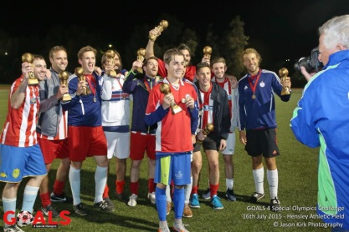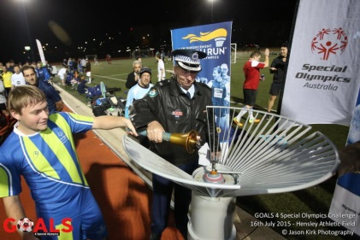
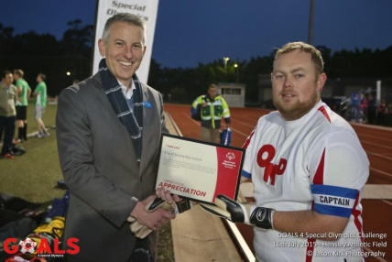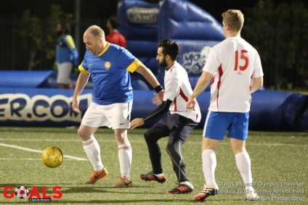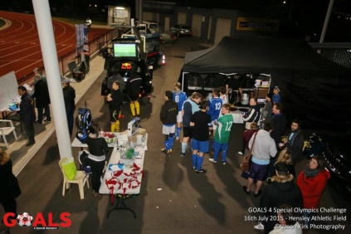
This is the second GOAL 4 SPECIAL OLYMPICS AUSTRALIA Event after 16 Corporate teams took part in the Mini-World Cup format in the first one in July at Hensley Athletic Field. The event will raise much needed funds and awareness for Special Olympics Australia, to support Australians with an intellectual disability to participate in weekly sports programs.
Squads will comprise a maximum of 12 players. Each team will play a minimum of three games and a maximum of six games. Round Robin games will be 20 minutes while the knock-out stages are 30 minute fixtures. It is also fully catered event with drinks provided.
For more information contact:
Andrew Paschalidis - Partnerships and Events Manager Level 3 - 215-225 Euston Road, Alexandria, NSW, 2015 Mobile 0467 764 598 Phone 1300 225 762 Email: andyp@specialolympics.com.au

